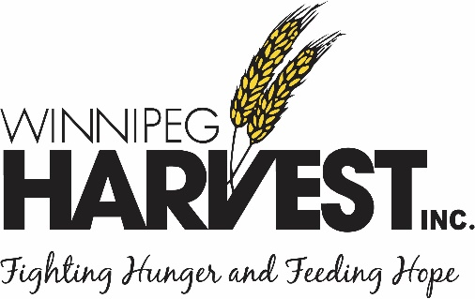


Backgrounder:

MMSM and Winnipeg Harvest launched the Bag it Forward: Plastic Bag Recycling Program in April 2015.

WHO IS MMSM?
MMSM is an industry-funded, not-for-profit organization that funds and operates province-wide residential recycling programs for packaging and printed paper, in accordance with the Packaging and Printed Paper Stewardship Regulation. Its goal is to promote the reduction, reuse and recycling of the materials managed in its program while increasing recovery rates.

WHAT IS IT?
MMSM and its members have been working diligently to reduce the number of plastic bags distributed in our province. The partnership between Winnipeg Harvest and MMSM provides Winnipeg and Manitoba residents with another convenient method to properly dispose of plastic bags by reusing them through the Bag it Forward Program and the repurposing bin they go into.

WHERE ARE THE PLASTIC BAGS GOING?
- There are 270 food distribution agencies that have plastic bag repurposing bins.
- The bins are located at Winnipeg Harvest and their affiliated food distribution agencies. including: Siloam Mission, Agape Table and Samaritan House in Brandon.
- There are an addition 30 bins at various local partners around the province.
- To date, 1,164pounds of plastic bags have been recycled (58,078 plastic bags).

WHAT IS BEING DONE WITH THE PLASTIC BAGS?
- The plastic bags will be reused at Winnipeg Harvest to create food kits and hampers. Each food distribution agency has their own criteria for what is done with the bags.
- Winnipeg Harvest has also established a recycling element for the bags that are donated but that cannot be used i.e. they are ripped or have holes in them. Those bags are recycled instead of going to landfill.

IMPORTANT NOTE: Winnipeg Harvest does not publish the names of the locations due to privacy.
View the Bag it Forward: Plastic Bag Recycling Program video: https://vimeo.com/125687358
For more information:

Chris Albi| Communications Manager| Winnipeg Harvest| media@winnipegharvest.org| 204-229-9660

Updated on March 20, 2017ca

